Golf Club Sport

Item No. | TH-IR98
Material | 303S.S
Brand | OEM/Customer's design is welcomed
Loft | Standard
Lie | Standard
Bounce | Standard
Finishing | Polishing
Logo | Engraved
Feature | Loft adjustable  Sample availables for test  Customized designs
Package | Inner Package: Individual PE plastic sheet
 | Outer Package: 48pcs/carton, neutral export standard carton(welcome custom design)
Lead Time | Sample: 2-3 weeks with logo
 | Order: 4-5 weeks after order confirmed

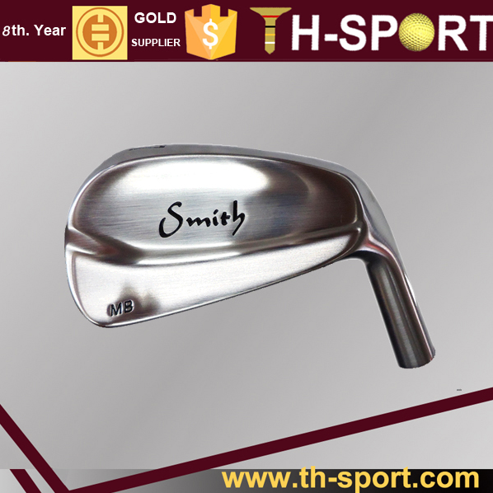

Packaging Detail:

48pcs/ctn
N.W.: 9.6kgs; G.W.: 11kgs; M.: 45*52*27

Company Information:

1998---A family business, a golf bag workshop, was founded, focusing on the local Chinese market.
2005---Moved to new 5000 square meter factory, employing 200 workers, with a production capability,
to produce 5000pcs per month.
2006---TH-SPORT (H.K.) was established, started to export our products world wide.
2008---Became partners with Grip, Glove, Cap & Umbrella factories.
2009---Started doing business with, Maxfli, Mercedes-Benz, Jaguar, Cleveland,Tommy Armour, Dunlop,
Hippo, Hello Kitty,Yamamoto, Ecco and a range of smaller companies.
2010---Opened a show room, to display all we have, on the pretty

